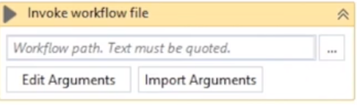

Right click and select “Extract as Workflow”

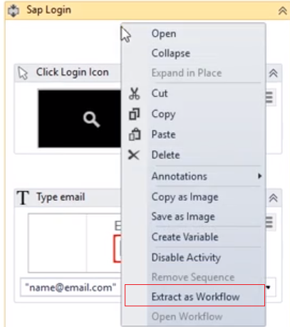

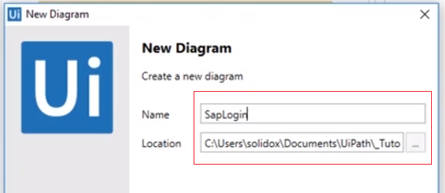

Creates a new diagram that can be invoked



